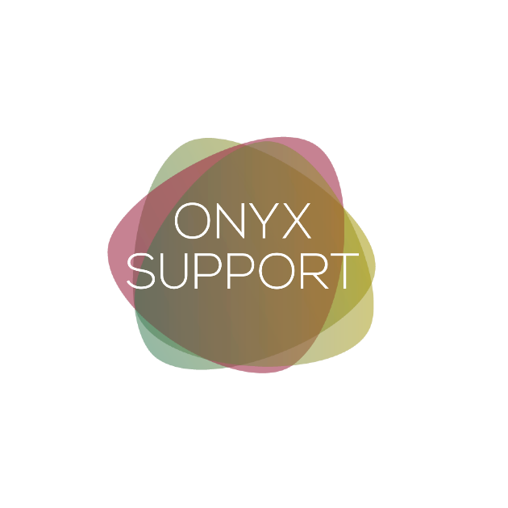

Freelancer FAQs

What age range will I be working with?
You will be working with students who are in Further Education (16-18) and Higher Education Students (18+).

How will I receive work?
We would let you know about referrals in and around your area (home visits and university visits) and you can accept and decline as you wish. You do not need to contact us for referrals we will notify you as they arise within your area and for suitable remote referrals.

What is the process once registration is complete, am I guaranteed work?
Freelance work is not guaranteed however we will get in touch with you as suitable referrals arise and we aim to build your caseload up as much as possible. Referrals are most likely to be received at the beginning of any academic year but we do receive referrals all throughout the year.

Where may I be working? / Which locations may I be working?
You may be working in educational settings such as a university or college in a 1:1 confidential room. You may also be carrying out home visits or working online. The location of this depends on each individual referral, we will let you know referrals local to your address and you can accept and decline as you wish.

Can I work online only?
There is an option to work online only, however there may be significantly less work available to you with this option. For some roles/students, online working is not available.

How long will I work with a student for?
You will work with the student from their support start date until their course end unless for other reasons you are unable to continue with them until their course end. On average this is around 3 years but depends on the support type. E.g., Assistive Technology Trainers will work with their students most likely at the beginning of the referral and complete the training within a few weeks, depending on the student’s preference.

How much paperwork is expected?
Timesheets are required to be signed following each support session. For Study Skills Tutors and Mentors, work plans must be completed in every 3 months from the initial session with each student.

How regular is supervision?
When you are supporting a student/s, supervision is every 6 months and within this we will look at your caseload including achievements, concerns (including safeguarding) as well as personal wellbeing. We do not charge for supervisions.

What happens if a student cancels the session?
If you are made aware of the cancellation with more than 24-hour notice then you will be able to reschedule (if possible) and the student will not lose any funded hours. If the student cancels within 24 hours then you are able to claim for a missed session and will still be paid for this. If this happens twice in one term than you are required to notify the admin team on admin@onyxstudents.com to enable this to be discussed with the student.

When is the timesheet deadline date each month?
Timesheets are due on the Friday before the 19th of every month. E.g., If the 19th falls on the Sunday, timesheet deadline would be Friday the 17th.

Can I provide multiple roles with Onyx?
Yes, as long as you have the mandatory requirements. Please get in touch for further opportunities with us. You can see the list of roles and their mandatory requirements on the ‘Mandatory Qualifications’ document.

How many hours will I be working with a student?
For Assistive Technology Training, it will be the amount of recommended hours of training (usually between 3-24 hours per student).
Each student is recommended an amount of hours per academic year which need to considered appropriately based on the role and the students needs.
Practical Support Worker, Sighted Guide, Lab Assistant, Note Taker, Exam Support, Communication Support Work and BSL Interpreting – hours recommended will be scheduled based on their timetables. Whereas for other roles such as Study Skills, Mentoring, Specialist Support (VI/HI/MSI), Study Assistance - hours are recommended based on the students needs and distributed across the academic year, determined between the student and yourself. E.g., they may not want support over the Christmas period but like more support during their exams.

What does it mean to be a freelancer?
As a freelancer you:
- are classed as self-employed.
- provide a service on our behalf. (You may provide a service to several providers)
- are responsible for paying your own taxes.
- are not entitled to the same rights of an employee would be entitled too. However, we have a duty to ensure you are treated fairly, with respect and not discriminated against.
- are responsible for registering your self-employment status with HRMC. Register for Self Assessment: Register if you’re self-employed - GOV.UK (www.gov.uk) Please note, you do not have to register as self-employed until you have been allocated a student and your income is greater than £1,000.
You will be given a unique tax reference number (UTR) once you have registered your self-employment status. The number will be unique to you and you will be required to use it when you are completing your Self-Assessment.
You will be required to complete annual Self-Assessments. If you fail to complete your self-assessment you will incur charges. A self-assessment is a declaration of your incomings and outgoings (revenue and expenses) in relation to your self-employment. Your expenses are deducted from your income to calculate how much profit (or loss) you made from self-employment. Your tax liability is then calculated from your profit minus your personal allowance.
Personal Allowance: Income Tax rates and Personal Allowances : Current rates and allowances - GOV.UK (www.gov.uk)
If you register as self-employed and in the future you no long wish to trade as self-employed you will need to contact the HMRC to let them know your new status.
You can be both self-employed and an employee (PAYE). If you are both an employee and self-employed, you will still need to tell HMRC and register for Self-Assessment.

If you have any further questions, please contact us on recruitment@onyxstudents.com

